Task 8.4

Isaac Pittolo – 7695438  
Hoang Linh Bui – 100017631  
Adam Bubonya – 9986677

# Team’s Velocity

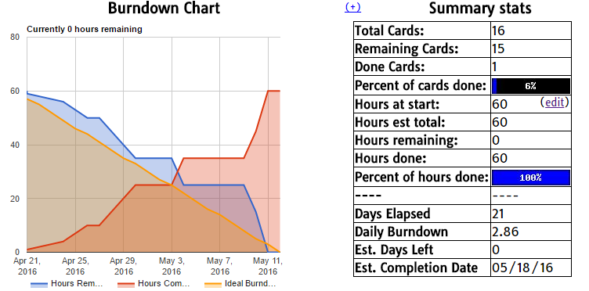

Ideally, we should have had a straight line, where our hours remaining was completed considerably more “smoothly” then it actually occurred. It is not feasible to have a consistent work time for as we have other commitments outside of just this assessment. In a more professional environment where the sole focus for the sprint is just to complete software functionality, I would imagine the graph looking considerably more consistent.

## Did we overestimate our Abilities?

No. We knew what level we could operate at; there is a large variance between our skill levels, with Linh being significantly better than both Adam and Isaac. We knew at what level we could operate at and planned for that accordingly. This means that both Adam and Isaac had to spend many more hours working on the same task then Linh would have had to do.

We also understood the complexity of the task. This is no small feat and even producing a functional demo took considerable time and effort. While we are not overjoyed with our progress made, we did make a very good attempt and were very accurate in estimating how we would perform in this coming sprint.

## Task Complexity

If we had a bit more knowledge on managing a project at the beginning we would have been able to perform better, which is the purpose of this subject. After having completed two sprints, we now know the expectations and what will be required of us in the future. We can definitely better assess the complexity of a given task in the future.

We underestimated how difficult and complex it is to set up test cases as well as run them. We found that we were allocating too much to one person to test and we should have broken the tasks down into more pieces. Things like grouping “variable testing” for string types were placed into one tasks when they should have been many separate tasks.

Dedicating time to working on the tasks was a small issue we had too. We assumed at the beginning that this assessment would be difficult to estimate, as it is quite different to anything we have done previously. If we had more experience and time to work out what we needed to do to understand the complexity, we would have done much better.

It would have also helped to record tasks and outcomes we have completed and using them as for similar tasks and projects as a comparison.

We also need to learn to ask for assistance when we need it. Swallow our pride a bit and ask our tutor or Linh for assistance when needed.

# Team’s Process

Face to face, communication was fine; we usually all attend our tutorials weekly to convey ideas. Our main method of communication, Slack and Skype had a few issues, which affected our team’s process. Slack helped a lot as it has integration with Skype and GitHub, but we did not know that it had a ‘sleep’ mode at 10pm, and did not notify you of anything happening afterwards.

Visual studio worked well for us, with a few small issues. It was not possible to find a version of Visual Studio for Macs, so Isaac was forced to install Visual Studio on a machine at home. The testing framework was broken as well – it would only occasionally work as expected and we could not figure out why it would not work.

GitHub was a good tool, it took some knowledge to understand how to use it which caused some delays but once we figured out what to do, everything went considerably more smoothly.

Now that we understand the tools we were using we probably will not run into as many issues in any future sprints.